Create User (UC-01)
Use case
Uc Name | UC-01 – Create User Account
Summary | - Allows the system administrator to create a new user account for hospital staff and assign an appropriate role.
Dependency | - None
Actors | - Primary Actor: Administrator  Secondary Actors: HR Officer
Pre-conditions | - Administrator is authenticated in the system.  - Administrator has permission to manage user accounts.
Description of the main sequence | - Step 1: Administrator navigates to the user management section.  - Step 2: Administrator selects "Create New User".  - Step 3: Administrator enters user details (name, role, username, contact information).  - Step 4: Administrator assigns a system role.  - Step 5: Administrator confirms account creation.  - Step 6: System stores the user account in the database.  - Step 7: System displays confirmation message.
Alternative Sequence | - Step 1: Administrator enters incomplete or invalid data.  - Step 2: System displays validation error.  - Step 3: Administrator corrects the information and resubmits.
Non-functional Requirements | - User account creation must complete within 2 seconds.  - Access must be restricted to authorized administrators.  - User credentials must be securely stored.
Post-Conditions | - A new user account is successfully created in the system database.
Activity Diagram
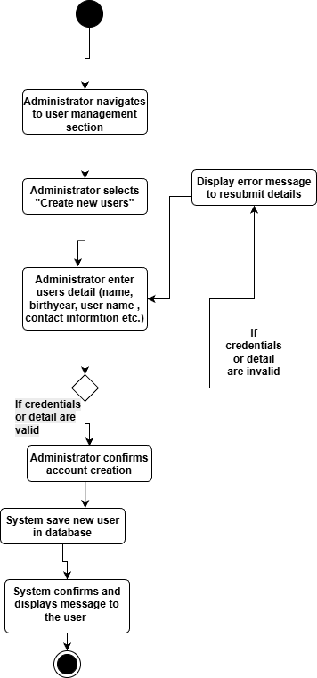

Administrator State Diagram
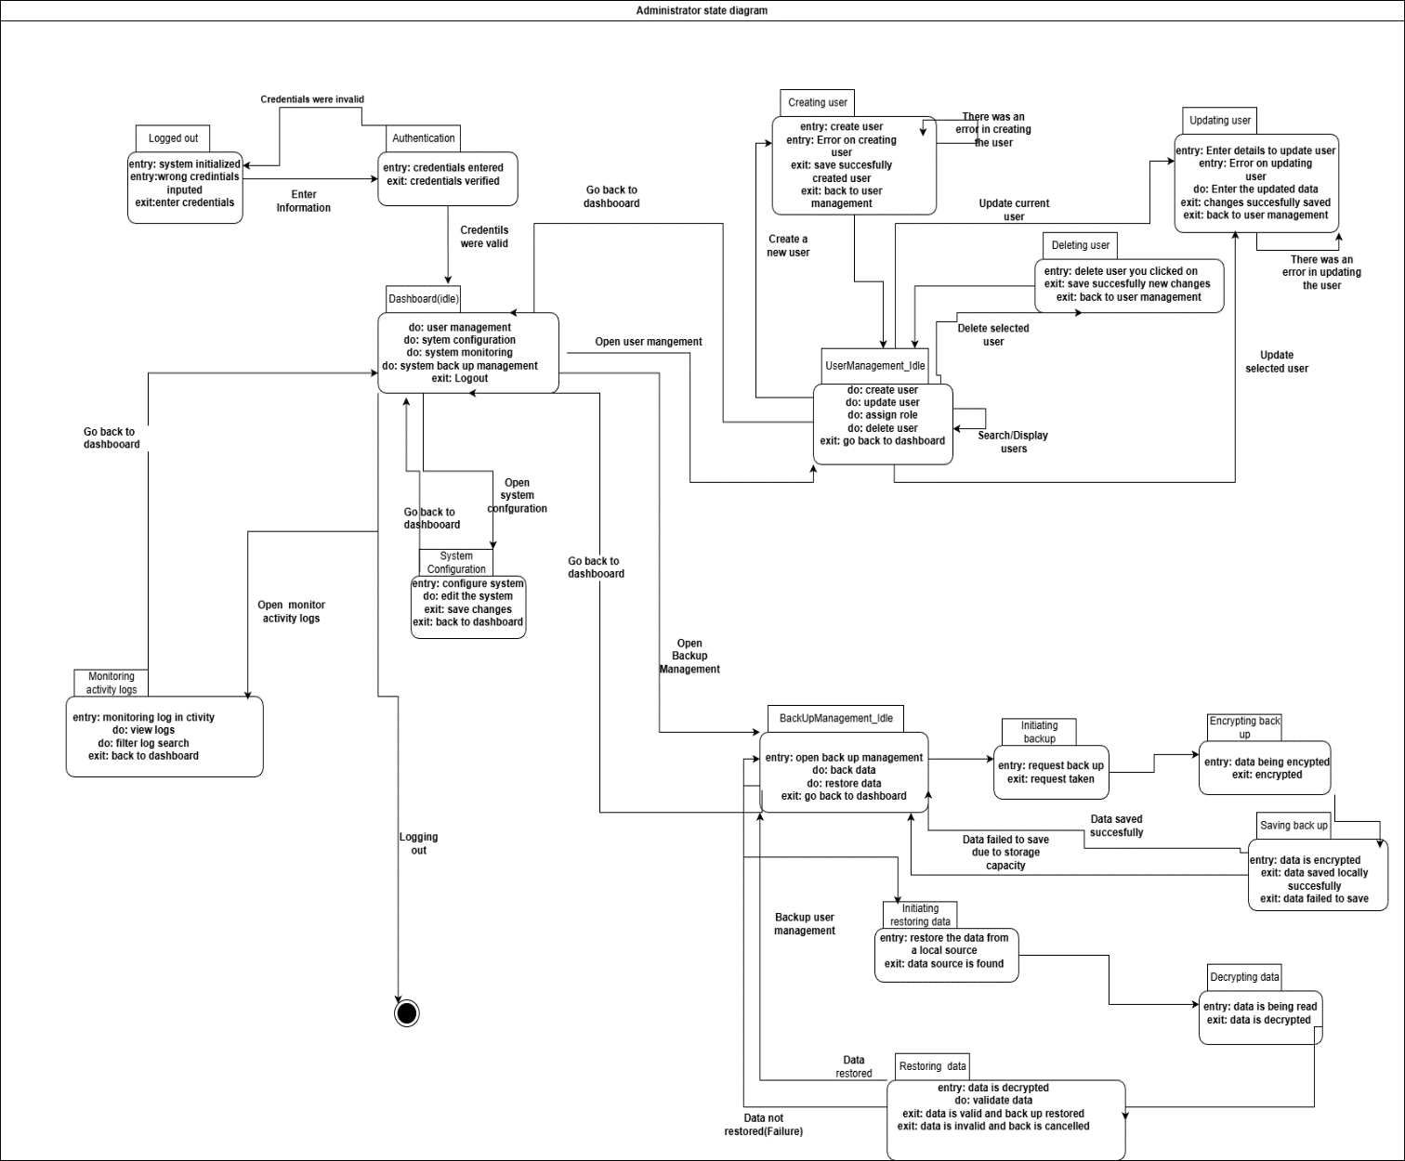

Sequence Diagram
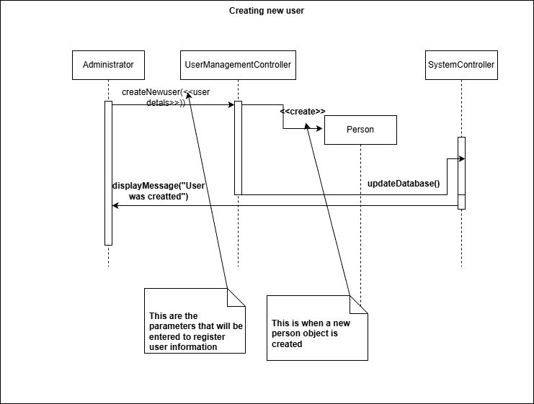

Collaboration Diagram
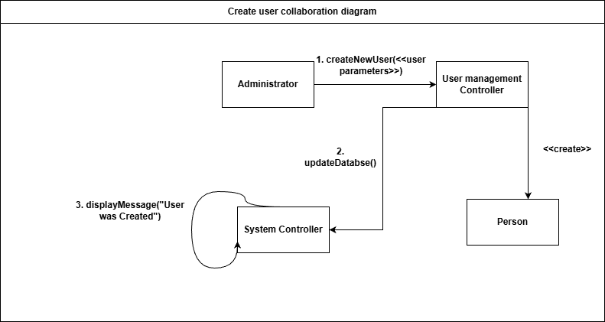

Process Staff payment (UC-40)
Use Case
Uc Name | UC-40 – Process Staff Payroll Payments
Summary | Allows HR Officers to process payroll payments
Dependency | Requires staff salary records to be available and approved in the system.
Actors | Primary Actor: HR Officer
Pre-conditions | - HR Officer is logged in.  - Salary data exists.
Description of the main sequence | - Step 1: HR Officer opens payroll section.  - Step 2: HR Officer selects payroll period.  - Step 3: System calculates payments.  - Step 4: HR Officer confirms payment.  - Step 5: System processes payments.
Alternative Sequence | - Step 1: Missing salary data.  - Step 2: System shows error.
Non-functional Requirements | - System must be reliable and secure.
Post-Conditions | - Payments are completed.

Activity Diagram
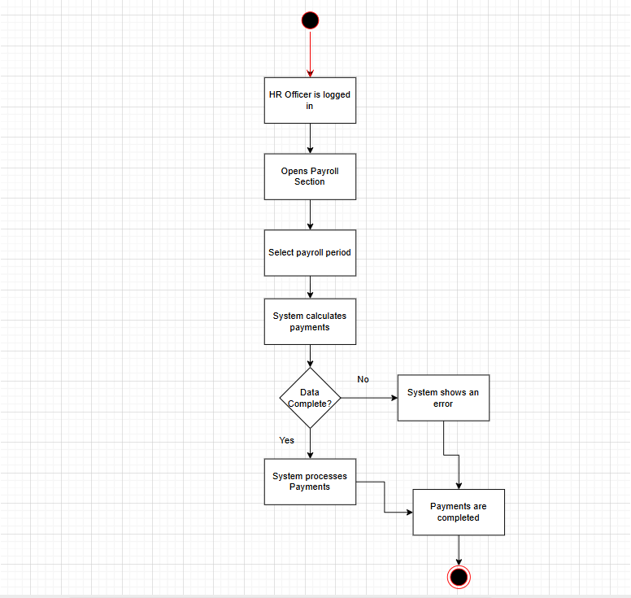

Hr officer State Diagram
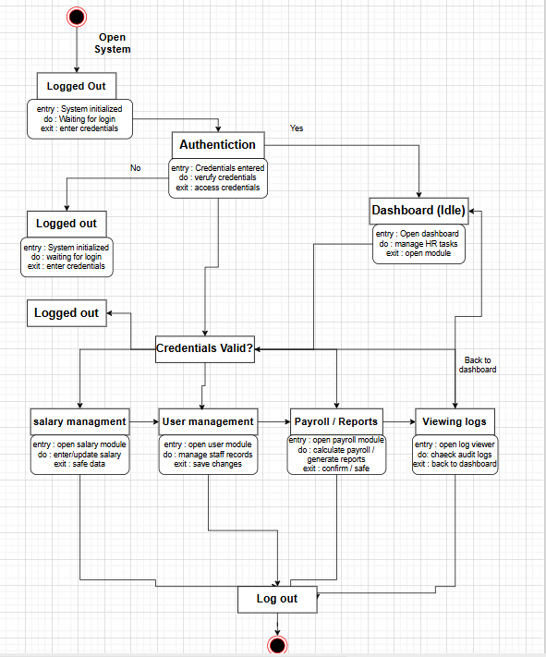

Collaboration Diagram
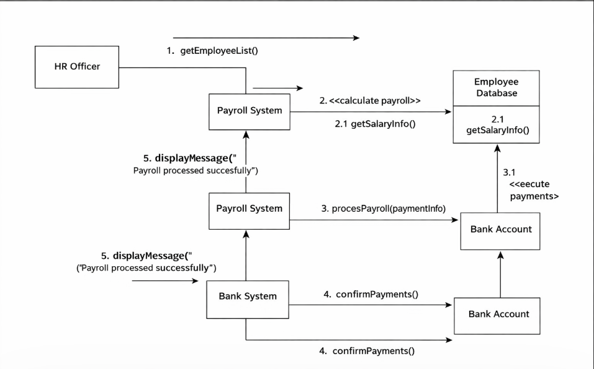

ERD
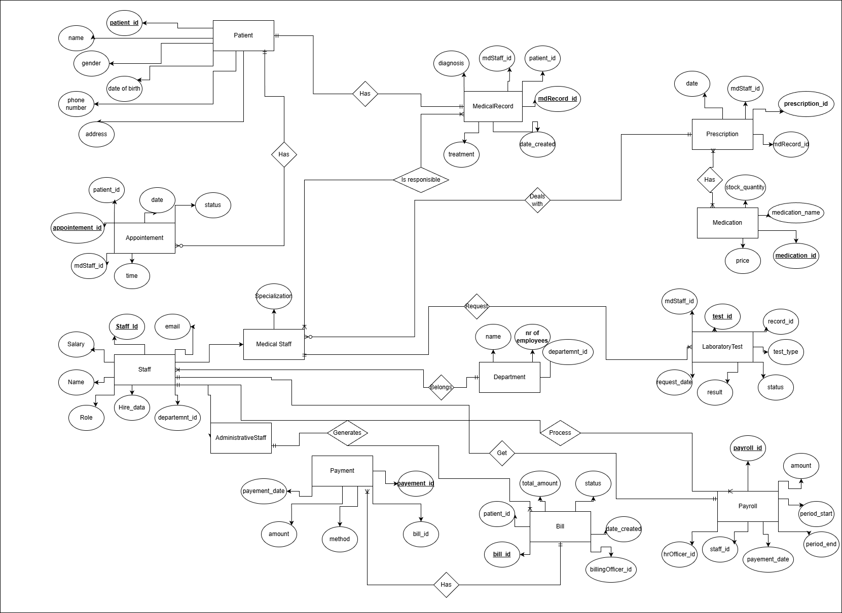

Class Diagram
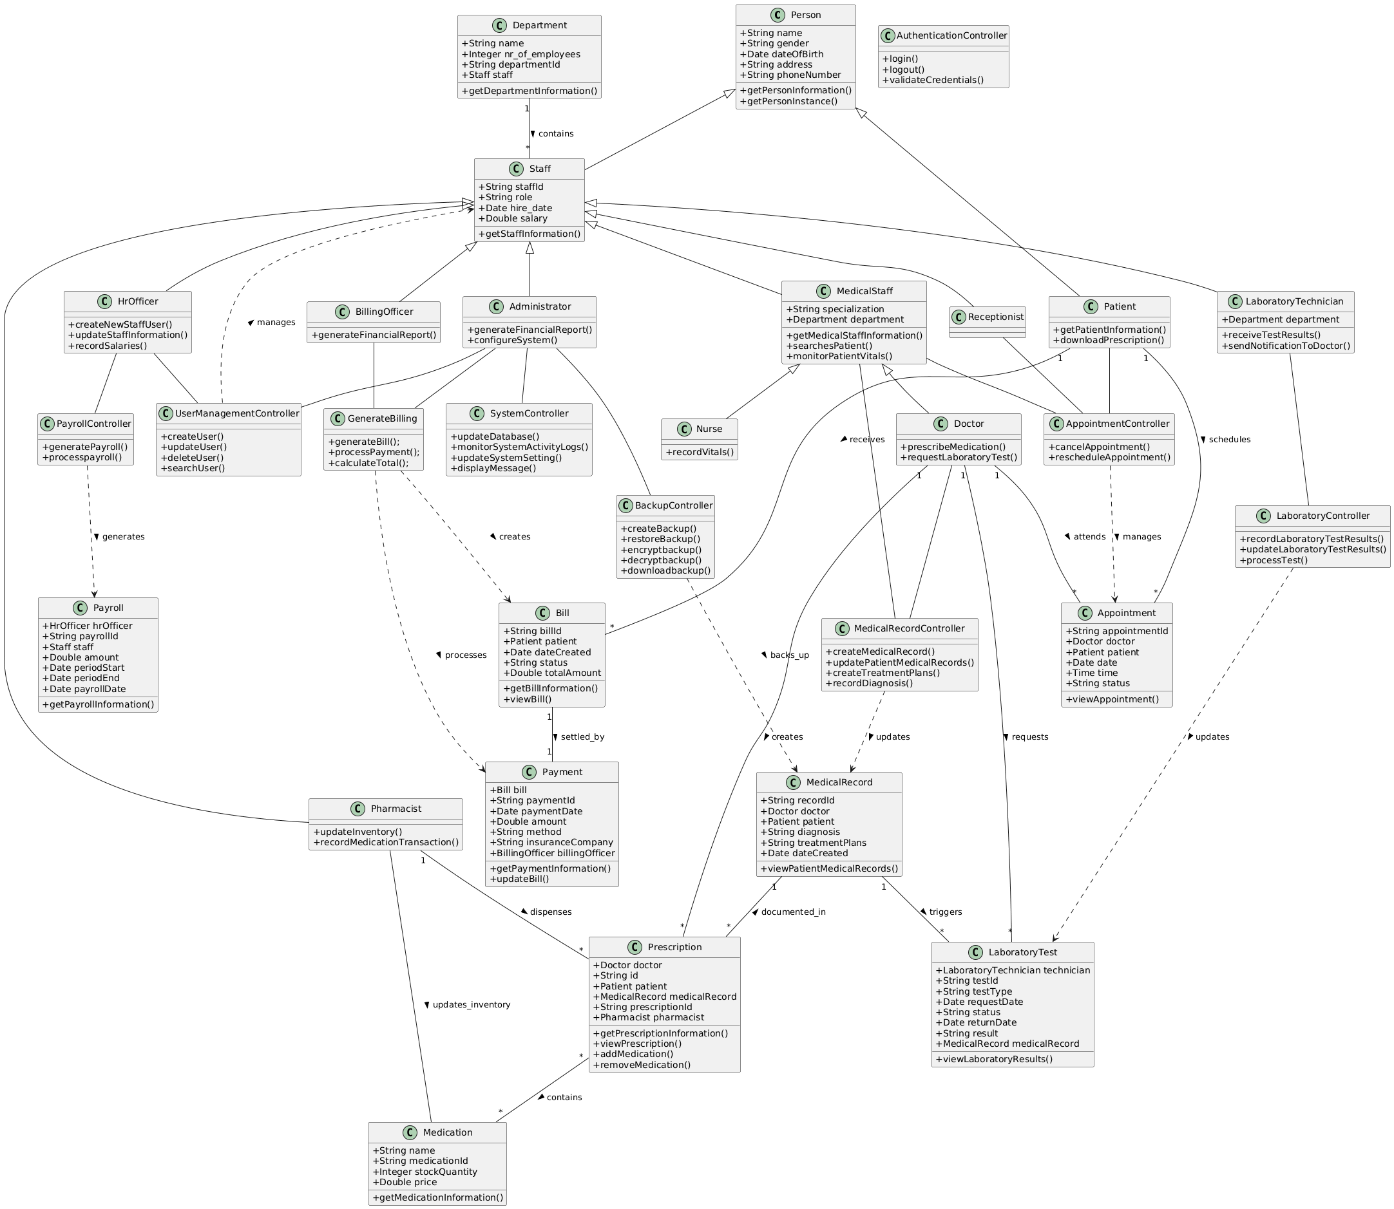

BPMN Diagram
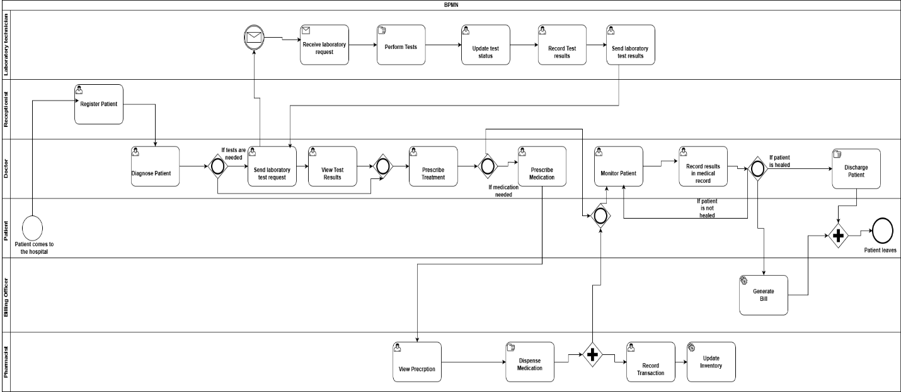

IOD DIAGRAM
